# Integrate Rational DOORS and Rational Team Concert change management

<https://www.ibm.com/developerworks/rational/library/integrate-rational-doors-and-rational-team-concert-change-management/>

<https://www.ibm.com/developerworks/rational/library/integrate-rational-doors-and-rational-team-concert-change-management/integrate-rational-doors-and-rational-team-concert-change-management-pdf.pdf>

*Improve requirements management and traceability*

Learn how you can use the IBM® Rational® DOORS® Change Management integration feature in either Basic or OAuth modes to communicate with IBM® Rational Team Concert™ collaborative change management software. It covers the entire process, from configuration, through features for gathering requirements, to the implementation phase of the requirements, all to help you achieve complete traceability of requirements. It is intended for readers who have an intermediate level of knowledge of Rational DOORS and Rational Team Concert software.

**Prerequisites**

You will gain the most from this tutorial if you have intermediate-level knowledge of IBM® Rational Team Concert™, IBM® Rational® DOORS®, and the DOORS change management integration feature.

* **Rational Team Concert** is a collaborative project management tool for software developers. It integrates work item tracking, builds, source control, and agile planning.
* **Rational DOORS** is a requirements management tool for systems and advanced IT applications. You can use it to gather, track, and manage requirements. It supports [OSLC](http://open-services.net/html/Home.html) (Open Services for Lifecycle Collaboration) specifications for change management thereby providing a generic approach to integrate systems and software lifecycle tools. It also supports [OAuth](http://oauth.net/), which is an open protocol that enables users to share their protected resources among different web sites without risking exposure.
* **The Rational DOORS** [Change Management integration](http://public.dhe.ibm.com/common/ssi/ecm/en/rad14034usen/RAD14034USEN.PDF) works with Rational Team Concert, IBM® Rational® ClearQuest®, and IBM® Rational® Change software.
* [Rational DOORS Web Access](http://www.ibm.com/software/awdtools/doors/webaccess/) enables users to use a web browser to create, review, edit, and discuss requirements held in a DOORS database.

Before you start, you need this software and setup:

1. Rational DOORS server and client installed.
2. Rational DOORS Web Access installed and configured with the DOORS server.
3. Rational Team Concert installed.
4. Rational® Jazz™ Team Server set up in Rational Team Concert.

[Back to top](https://www.ibm.com/developerworks/rational/library/integrate-rational-doors-and-rational-team-concert-change-management/#ibm-content)

**Installation and configuration**

**Install DOORS and the Change Management integration tool**

1. Extract the **installer** .zip file to a temporary location.
2. Edit the **install.bat** file if DOORS is installed in a different location than this:

Set to="C:\Program Files\IBM\Rational\DOORS\9.3"

1. Save the changes that you made to the file, if any.
2. Run the **install.bat** batch file.

The installer will then display the command prompt view shown in Figure 1, which tells you to exit the DOORS client before proceeding and says to press any key to continue.

**Figure 1. Command prompt view with instructions**

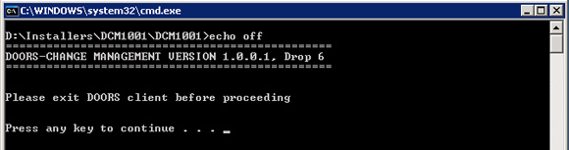

1. Press any key to continue.

The screen then displays the DOORS_HOME details (see Figure 2), with this message:

"Please verify the location of the installer and DOORS client before proceeding.  
  
Press any key to continue."

**Figure 2. Another command prompt view with instructions**

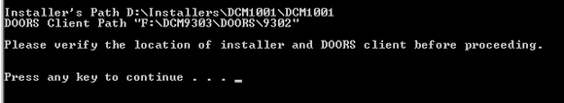

1. If the DOORS home details displayed are correct, press any key to continue.

After the integration is installed, the cmoslclib.dll file gets registered, and you will see a confirmation message, as Figure 3 shows.

**Figure 3. DllRegisterServer confirmation message**

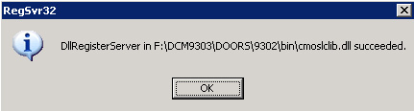

**Configure server files in Rational Team Concert for Basic mode**

By default, Rational Team Concert enables the Form mode.

**Modify server files in Rational Team Concert to enable Basic mode**

To enable Basic authentication, follow these steps:

1. Shut down Rational Team Concert server:  
   *installationLocation*/jazz/server/server.shutdown
2. Edit the **web.xml** file: *installationLocation*/jazz/server/tomcat/webapps/jazz/WEB-INF/web.xml

Comment out the **Form** mode and uncomment the **Basic** mode, so that the file reads as code Listing 1 shows.

**Listing 1. Edited web.xml file**

<login-config>

<auth-method>BASIC</auth-method>

<realm-name>Jazz</realm-name>

</login-config>

<!--

<login-config>

<auth-method>FORM</auth-method>

<form-login-config>

<form-login-page>/auth/authrequired</form-login-page>

<form-error-page>/auth/authfailed</form-error-page>

</form-login-config>

</login-config>

-->

1. Edit the **jazz.xml** file: *installLocation*/jazz/server/tomcat/conf/Catalina/localhost/jazz.xml   
   Replace the FormAuthenticator with the BasicAuthenticator, as Listing 2 shows.

**Listing 2. Edited jazz.xml file**

<!--

<Valve className="org.apache.catalina.authenticator.FormAuthenticator"

securePagesWithPragma="false"

characterEncoding="UTF-8" />

-->

<Valve className="org.apache.catalina.authenticator.BasicAuthenticator"

securePagesWithPragma="false"

characterEncoding="UTF-8" />

1. Start the Rational Team Concert server:*installationLocation*/jazz/server/server.startup

**Create a user**

1. Launch the Mozilla Firefox or Microsoft Internet Explorer browser.
2. In the address bar, type this URL to start Rational Team Concert:  
   https://*QualiyfyingServerName*:9443/ccm/admin**Note:** Accept the *secured connection* certification.

**Create a user with all privileges in Rational Team Concert**

1. For the user ID and password, enter ADMIN and ADMIN, and then click **Log In**.
2. Click the **Users** link.
3. Click the **Create User** link.
4. Type in the new user details. (Enter the mandatory field details).
5. Select Repository Permissions and Client Access Licenses for the user, as shown in Figure 4 (the Client Access License is **Rational Team Concert - Developer**).
6. Click **Save**.

**Figure 4. Verify that the client access licenses are selected for the new user**

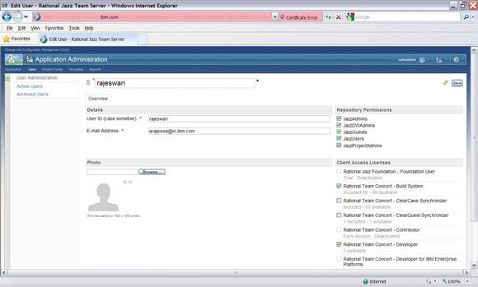

[Larger view of Figure 4.](https://www.ibm.com/developerworks/rational/library/integrate-rational-doors-and-rational-team-concert-change-management/fig04_lg.html)

**Create a project**

**Create a Rational Team Concert project with user access rights**

1. Launch Firefox or IE.
2. Type this location in the address bar to start Rational Team Concert:  
   https://QualiyfyingServerName:9443/ccm/admin  
   **Note:** Accept the *secured connection* certification.
3. Enter the User ID and password and then click **Log In**.
4. Click the **Project Areas** link.
5. Click the **Create Project Area** link.
6. Type the Project Name and Details.
7. In the Process section, select **Simple Team Process**
8. Add the user to the Members and Administration sections, as shown in Figure 5.
9. Then click **Save**.

**Figure 5. Create a Project Area in Rational Team Concert**

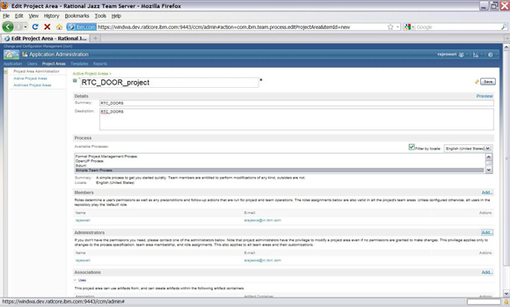

[Larger view of Figure 5.](https://www.ibm.com/developerworks/rational/library/integrate-rational-doors-and-rational-team-concert-change-management/fig05_lg.html)

**Set project configuration and team member permissions**

1. Click the **Project Areas** link.
2. Double-click on the project that you created.
3. Click the **Permission** tab.
4. Select the **Project Configuration** option, and enable all permissions for the project for the team member, as shown in the Figure 6.

**Figure 6. Project configuration permission for the new project**

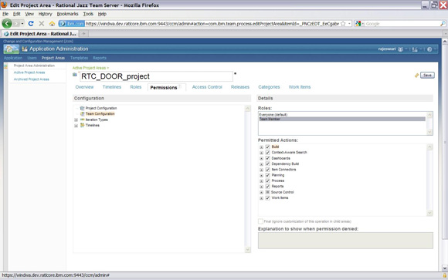

[Larger view of Figure 6.](https://www.ibm.com/developerworks/rational/library/integrate-rational-doors-and-rational-team-concert-change-management/fig06_lg.html)

1. Select the **Team Configuration** option.
2. Enable all team permissions on the project for the team member, as shown in the Figure 7.
3. **Save** the changes to the project.

**Figure 7. Team Configuration permission for the new project**

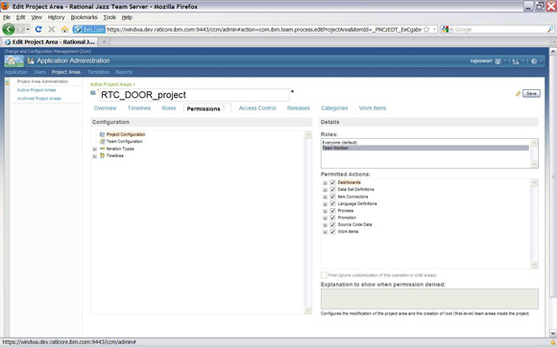

[Larger view of Figure 7.](https://www.ibm.com/developerworks/rational/library/integrate-rational-doors-and-rational-team-concert-change-management/fig07_lg.html)

**Create a repository connection**

1. Open the Rational Team Concert client.
2. Find and run the **eclipse.exe** file:  
   C:\Program File\IBM\jazz\client\eclipse\**eclipse.exe**
3. Select the workspace.
4. Click the **Create Repository Connection** link.

The next view will be the Create a Jazz Repository Connection dialog window shown in the Figure 8.

**Figure 8. Use the Rational Team Concert client to create a Jazz repository connection**

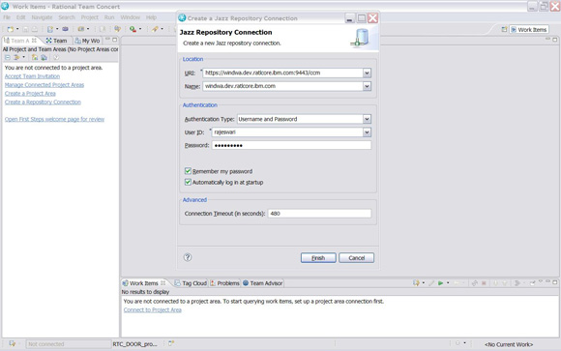

[Larger view of Figure 8.](https://www.ibm.com/developerworks/rational/library/integrate-rational-doors-and-rational-team-concert-change-management/fig08_lg.html)

1. Enter the Rational Team Concert server URL, for example:   
   https://*localhost*:9443/ccm  
   **Note:** The Name field details are automatically populated to localhost.
2. Enter the User ID and password.
3. Click **Finish**.

**Modify the process configuration**

1. Click the **Connect to Project Area** option.
2. Select the repository connection that you created.
3. Click **Next**.
4. Select the **Project Area** created.
5. Click **Finish**.
6. Select the repository, and click **Open**.
7. Click **Process Configuration** from the tabs at the bottom of the first pane (see Figure 9).

**Figure 9. Process Configuration tab in the new project**

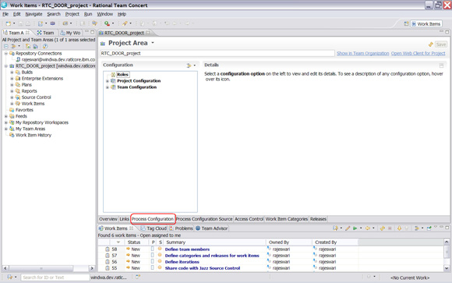

[Larger view of Figure 9.](https://www.ibm.com/developerworks/rational/library/integrate-rational-doors-and-rational-team-concert-change-management/fig09_lg.html)

1. Click the ***Project* Configuration** option.
2. Click **Configuration Data**.
3. Click the **Work Items** option.
4. Select **Workflows**.
5. Select **States** workflow.
6. Select **Resolved**, as shown in the Figure 10.

**Figure 10. Workflow configuration on the new project**

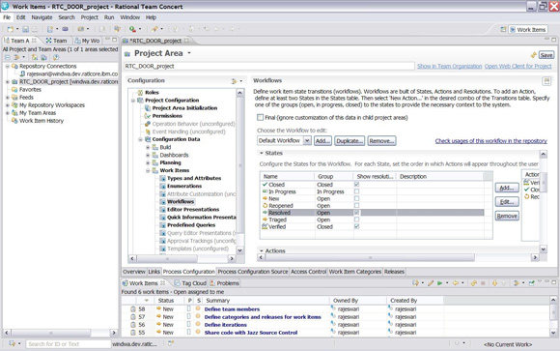

[Larger view of Figure 10.](https://www.ibm.com/developerworks/rational/library/integrate-rational-doors-and-rational-team-concert-change-management/fig10_lg.html)

1. Click **Edit**.
2. Change the Group field details from Closed to **Open**.
3. Click **OK**
4. Click **Save**.

**Create a configuration template in DOORS for Basic Auth**

1. Start the Rational DOORS client, and run the **doors.exe** file.
2. Log in to DOORS as a user with Database Administrator privileges.
3. Click **Change Management > Define Configuration Template** to display the Define Configuration Template dialog window.
4. In the Define Configuration Template dialog window, click **Create.**

**Configure Rational Change Management Server tab**

1. In the Step1: Configuration Rational Change Management Server tab, for Authentication type, select the **Basic Auth**, as shown in the Figure 11.

**Figure 11. Create a configuration template dialog in DOORS for Basic Auth**

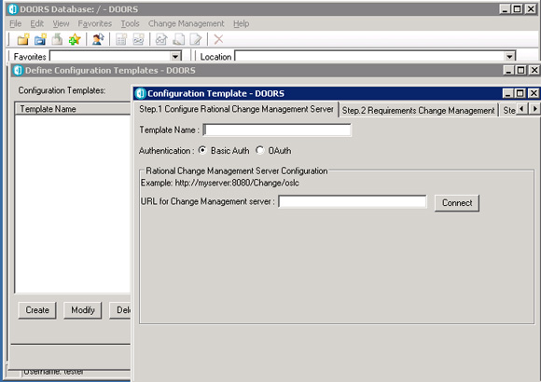

1. Enter the template name details.
2. Enter the URL for the Rational Team Concert Change Management server.   
   Example: https://QualifyingServername:9443/ccm/oslc/workitems/catalog
3. Click **Connect** to get the CM Login dialog window (Figure 12).

**Figure 12. CM Login window**

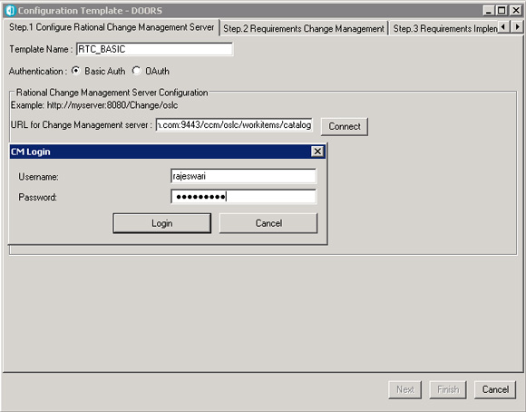

1. Enter username and password of the Rational Team Concert user in the CM login window, click **Login**.
2. Select the project from Project Area list (see Figure 13).

**Figure 13. Project Area details**

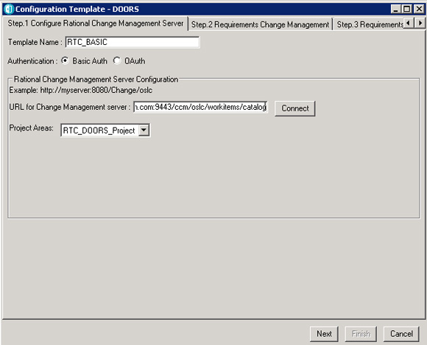

1. Click **Next** to navigate to Step2: Requirements Change Management tab.

**Requirements Change Management tab**

1. Enter the value details to map Rational Team Concert work items to their state details, which are always numeric.

The states and their respective state values are listed in Table 1.

**Table 1. States and values in Rational Team Concert**

| **State name** | **State value** |
| --- | --- |
| New | 1 |
| InProgress | 2 |
| Resolved | 3 |
| Verified | 4 |
| Closed | 5 |
| Reopened | 6 |

1. Select the **For Rational Team Concert** option.
2. Enter these values for the respective fields: Apply in
   * Apply Action Attribute: bugzillaWorkflow.action.close
   * Review Action Attribute: bugzillaWorkflow.action.resolve and in
   * State Attribute: rtc_cm:state
3. For the RCR Submit Form field, select **RequirementChangeRequest**, as shown in Figure 14.

**Figure 14. Requirement Change Management tab**

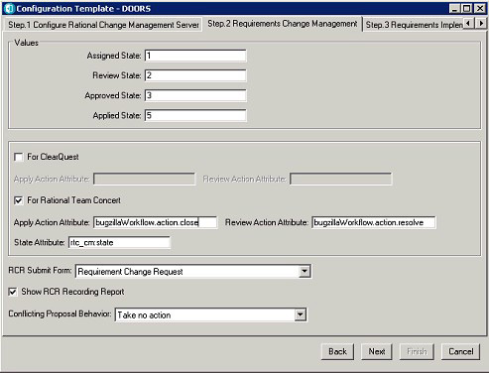

1. Click **Next** to navigate to the Step3: Requirements Implementation tab (Figure 15).

**Requirements Implementation tab**

**Figure 15. Requirement Implementation tab**

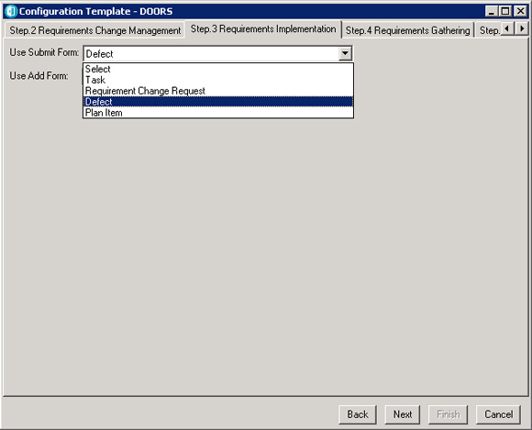

1. Choose the respective submit forms for Use Submit Form and Use Add Form options.
2. Click **Next** to navigate to the Step4: Requirements Gathering tab.

**Requirements Gathering tab**

1. Enter the query details for gathering requirements from Rational Team Concert.

**Tip:**  
The query format should be rtc_cm:state in ["2"], where "2" \ represents the *Inprogress* state of a work item in Rational Team Concert, as shown in the Figure 16.

**Figure 16. The Requirements Gathering tab the**

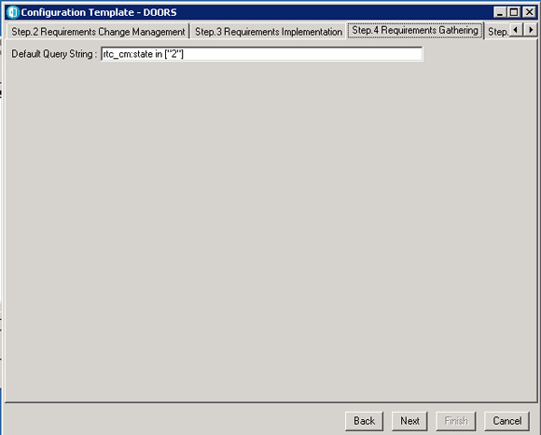

1. Click **Next**.
2. Verify the summary details, and then click **Finish**.

The Configuration Template gets created for DOORS and Rational Team Concert in Basic mode. The template gets listed in Define Configuration Templates dialog.

**Create a Friends (outbound) link in Rational Team Concert**

1. Launch IE or Firefox.
2. Type https://QualiyfyingServerName:9443/ccm/admin in the address bar to start Rational Team Concert.  
     
   Example: https://indpdt1-2k3r2.blorepd.in.ibm.com:9443/ccm/admin **Note:** Accept the *secured connection* certification.
3. Enter the user ID and password. Click **Log In**.
4. Click the **Application** link.
5. From the Communication tab, click the **Friends (Outbound)** link.
6. Click **Add** to open the Add Friend dialog window.
7. Create a Friends outbound link for change configuration management services, or CCM.
8. Enter the Name field details, and enter the ccm server URL in the Root Services field:  
   https://*QualiyfyingServerName*:9443/ccm/rootservices
9. Enter the OAuth Secret Key.
10. Select the check box so that the operation is Trusted, as shown in the Figure 17.

**Figure 17. Add Friend dialog on Rational Team Concert server**

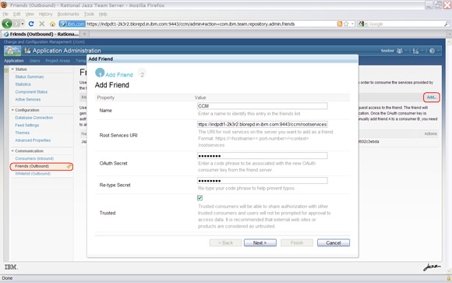

[Larger view of Figure 17.](https://www.ibm.com/developerworks/rational/library/integrate-rational-doors-and-rational-team-concert-change-management/fig17_lg.html)

1. Click **Next**.
2. The automatically generated provisional key value is displayed in Authorization Provisional Key dialog.
3. Click **Finish**. A link to the ccm services gets created in Friends (Outbound) list with automatic OAuth Consumer Key details.

**Configure the DOORS root server with the Rational Team Concert Friends link**

1. Start the Rational DOORS client by running **doors.exe**.
2. Log in to DOORS as a user with Database Administrator privileges.
3. Select the DOORS database and invoke the properties of the database.
4. In the DOORS Database Properties dialog window, click the **Remote Services** tab.
5. In the Server List section, click **Add**.
6. Enter the Rational Team Concert root services URL created in the friends list in the Roots Services URL field.
7. In the Consumer Key field, enter the auto-generated OAuth Consumer Key that was generated for the respective Friends link of Rational Team Concert.
8. Enter the OAuth secret key value.
9. Click **Register**, as shown in Figure 18.

**Figure 18. Create Server List in Remote Services through DOORS**

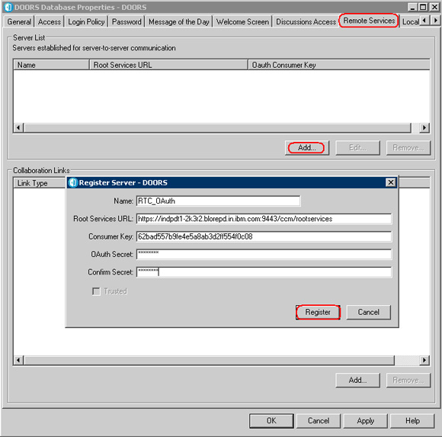

[Larger view of Figure 18.](https://www.ibm.com/developerworks/rational/library/integrate-rational-doors-and-rational-team-concert-change-management/fig18_lg.html)

1. After the service list for Rational Team Concert ccm root services gets registered, click **Add** in the Collaboration Links section.
2. In the Add Service Link Types dialog window, select the **Server List** link.
3. Enter user ID and password credentials in the Rational Team Concert server login window and then click **Log in** (see Figure 19).

**Figure 19. OAuth Login view while creating a Collaborative Link**

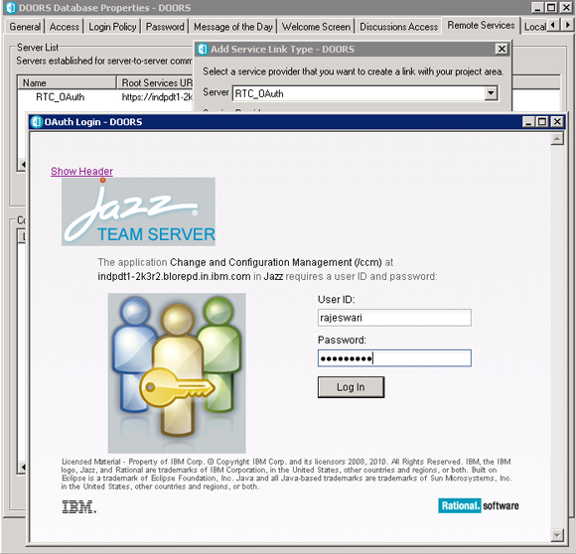

1. Click **Add** in the Collaboration Links section.
2. Select the database available in Rational Team Concert, and click **Add**.
3. After the collaborative link gets created, click **OK** to close the DOORS Database Properties dialog window.

**Create a configuration template in DOORS for OAuth**

1. Select **Change Management > Define Configuration Template**.
2. In the Step1: Configure Rational Change Management Server tab, provide the template name details.
3. Select the **OAuth** option for Authentication.
4. Select the server link created for Rational Team Concert in the Select a CM Tool field, as shown in the Figure 20.

**Figure 20. Create Configuration template dialog in DOORS for OAuth**

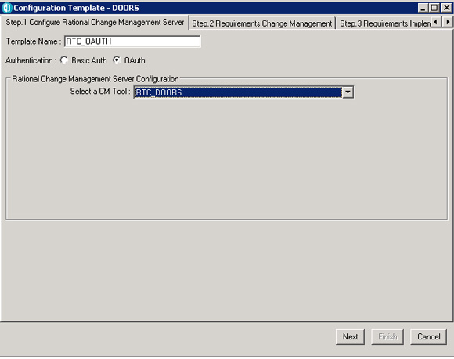

1. Click **Next**, and follow the procedure from Step 11, under [Create a configuration template through the Basic mode](https://www.ibm.com/developerworks/rational/library/integrate-rational-doors-and-rational-team-concert-change-management/#_Create_a_configuration).

[Back to top](https://www.ibm.com/developerworks/rational/library/integrate-rational-doors-and-rational-team-concert-change-management/#ibm-content)

**Requirements traceability**

**Gather requirements from Rational Team Concert for DOORS**

1. Start the Rational DOORS client by executing **doors.exe**.
2. Log in to DOORS as a user with Database Administrator privileges.
3. Create a formal module in DOORS, using the default template.
4. Open that module.
5. Select **Change Management > ConfigureModule**.
6. Select the configuration template for Rational Team Concert.
7. Change Integration Status to **ON**.
8. Select **Enable Requirement Gathering**, as shown in Figure 21.
9. Then click **Save**.

**Figure 21. Configure Module for Change Management view in DOORS**

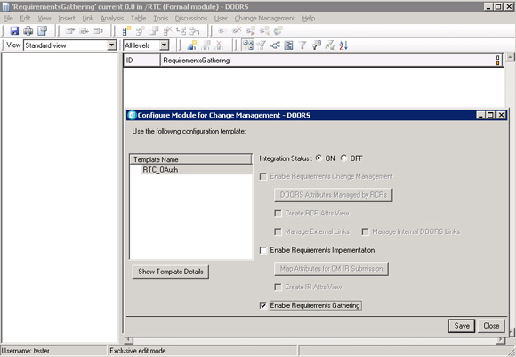

[Larger view of Figure 21.](https://www.ibm.com/developerworks/rational/library/integrate-rational-doors-and-rational-team-concert-change-management/fig21_lg.html)

**Retrieve requirements from Rational Team Concert**

1. Select **Change Management > Retrieving Requirements for Change Management tool > Define Attribute Mapping**.
2. Select **DOORS Attribute**, and click **Edit**.
3. Choose the CM Attribute, and then click **Close**, as shown in the Figure 22.

**Figure 22. Attribute mapping selections in DOORS**

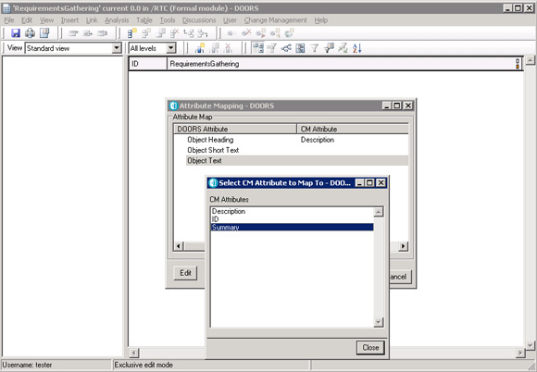

[Larger view of Figure 22.](https://www.ibm.com/developerworks/rational/library/integrate-rational-doors-and-rational-team-concert-change-management/fig22_lg.html)

1. Click **OK** after the attribute mapping is finished.
2. Select **Change Management > Retrieving Requirements for Change Management tool > Get Requirements**.
3. Verify the Query String, and then click **Import**, as shown in Figure 23.

**Figure 23. String entered previously entered in the Query String field**

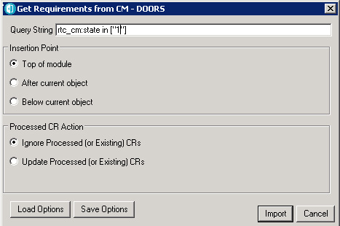

1. After the requirements are imported to the DOORS formal module, from Rational Team Concert, click to **Save** the module.

**Note:** You can also add requirements to the module manually.

**Manage a Requirements Change Request**

**Enable Requirements Change Request on the module**

1. Start DOORS client, by executing **doors.exe**.
2. Log in to DOORS as user with Database Administrator privileges.
3. Create a formal module in DOORS using the default template.
4. Open the formal module.
5. Click **Change Management > Configure Module**.
6. Select the configuration template for Rational Team Concert.
7. Set Integration Status to **ON**.
8. Select the **Requirements Change Request** option, as shown in the Figure 24.

**Figure 24. Configure the module for a Requirements Change Request**

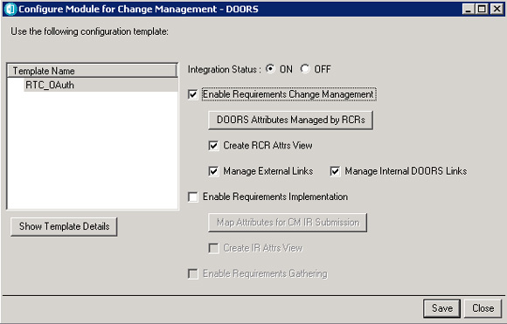

1. Click **Save**.

**Submit the default Requirement Change Request**

1. Open the formal module in DOORS in read-only.
2. Click **Change Management > Requirements Change Request > Submit**.
3. Enter details in the Submit Request dialog window, as shown in the Figure 25.

**Figure 25. Submit Request form for the Requirements Change Request**

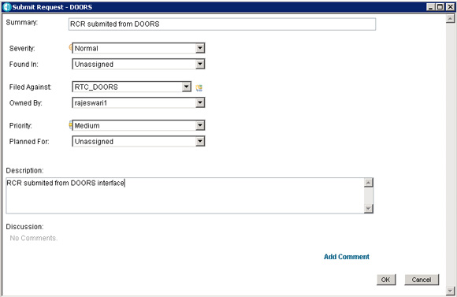

[Larger view of Figure 25.](https://www.ibm.com/developerworks/rational/library/integrate-rational-doors-and-rational-team-concert-change-management/fig25_lg.html)

1. Click **OK** to submit the Requirement Change Request.
2. Enter the user ID and password for Rational Team Concert login and click **Log In**.
3. View the Requirements Change request details submitted.
4. Click **Logout** to exit from Rational Team Concert, and close the browser.
5. Invoke the formal module in DOORS, and select **Change Management > Requirements Change Request > Select Default**.
6. Select the Requirements Change Request, and click **OK**.
7. Modify the object details in the formal module, and then click **Save**.

The Recording Report view displays the changes made to the module, as shown in the Figure 26.

**Figure 26. Recording Report in Rational DOORS**

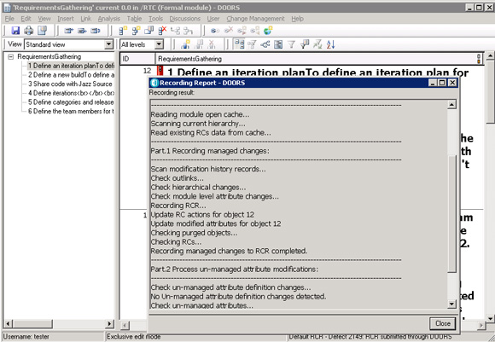

[Larger view of Figure 26.](https://www.ibm.com/developerworks/rational/library/integrate-rational-doors-and-rational-team-concert-change-management/fig26_lg.html)

**View changes made to the module**

1. Open the formal module in DOORS in Exclusive edit mode.
2. Select **Change Management > Requirements Change Request > Show for this module**.
3. Select the Requirement Change Request, and click **Show**.
4. Enter the Rational Team Concert user ID and password of, and click **Log In**.
5. Click the **Links** tab. This displays the DOORS Web Access link details under the Tracks Requirements section, as shown in the Figure 27.

**Figure 27. Links tab of Requirements Change Request in Rational Team Concert**

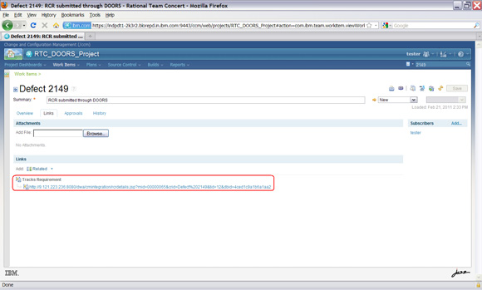

[Larger view of Figure 27.](https://www.ibm.com/developerworks/rational/library/integrate-rational-doors-and-rational-team-concert-change-management/fig27_lg.html)  
**Note:** The steps only work on IE.

Clicking on the link in the Tracks Requirements section redirects you to DOORS Web Access, as shown in the Figure 28.

**Figure 28. DOORS Web Access login screen**

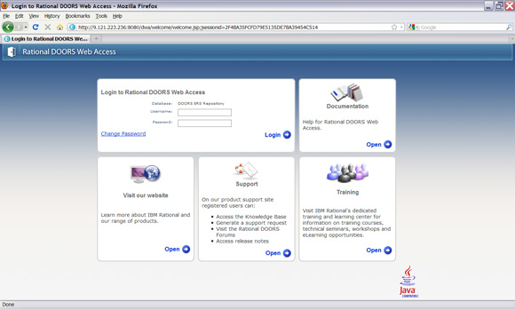

[Larger view of Figure 28.](https://www.ibm.com/developerworks/rational/library/integrate-rational-doors-and-rational-team-concert-change-management/fig28_lg.html)

1. Enter the username and password details for DOORS Web Access, and then click **Login**.
2. When you get a prompt, install the ActiveX Control.

After login, the list of Requirement Changes made to the module and the details are displayed. As Figure 29 shows, the Requirement Change details contain the DOORS URL for the respective object.

**Figure 29. Requirements Change details through DOORS Web Access**

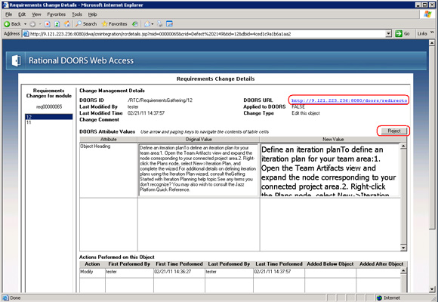

[Larger view of Figure 29.](https://www.ibm.com/developerworks/rational/library/integrate-rational-doors-and-rational-team-concert-change-management/fig29_lg.html)

**Note:**  
Clicking the DOORS URL link redirects you to the respective object in the formal module.

1. Click the **Reject** to reject the changes made to the requirement.
2. Click **OK** in the confirmation dialog, to confirm rejecting the changes made.
3. Click **OK** in the DOORSRCMCONTROL dialog window.

The requirement modification gets rejected, as you can see in Figure 30.

**Figure 30. Rejected Requirements Change as seen in DOORS Web Access**

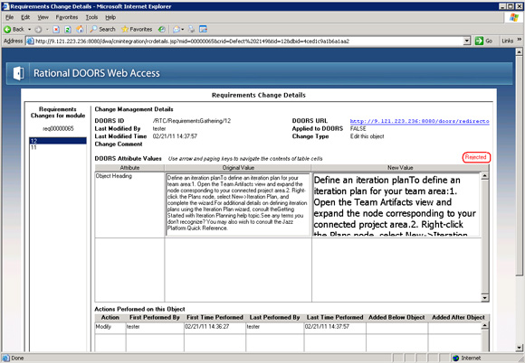

[Larger view of Figure 30.](https://www.ibm.com/developerworks/rational/library/integrate-rational-doors-and-rational-team-concert-change-management/fig30_lg.html)

**Send the Requirement Change Request to the Review state**

1. Open the formal module in DOORS in **Exclusive Edit.**
2. Complete the changes made to the formal module.
3. Click **Change Management > Requirements Change Request > Send RCR to Review** to send the Requirement Change Request to review state. as shown in the Figure 31.

**Figure 31. Review confirmation in DOORS**

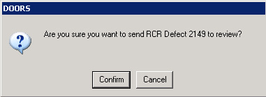

You can click **Confirm** to send the RCR for review or click **Cancel** to cancel the review process.

1. Send RCR to review.
2. Launch IE or Firefox.
3. Type this URL in the address bar to start Rational Team Concert:  
   https://QualifyingServername:9443/ccm/  
   **Note:** Accept the *secured connection* certification.
4. Enter the user ID and password, and click **Log In**.
5. Enter the Requirements Change Request ID in the search dialog, and view the defect details.
6. Click the **Approval** tab and then the **New: Approval** link to add the approver of the Requirements Change Request.
7. Enter the Approver name and due date, as Figure 32 shows.

**Figure 32. Requirements Change Request Approvals tab, Rational Team Concert**

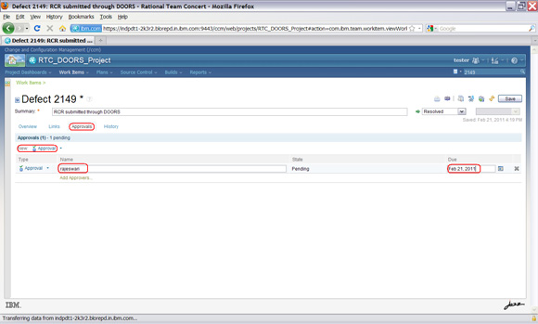

[Larger view of Figure 32.](https://www.ibm.com/developerworks/rational/library/integrate-rational-doors-and-rational-team-concert-change-management/fig32_lg.html)

1. Click **Save** and log out of Rational Team Concert.
2. As an approver of the Requirements Change Request, approve the changes.
3. Transition the Requirement Change Request to the **Resolve** state, as shown in the Figure 33.

**Figure 33. Approved state of Requirements Change Request, in Rational Team Concert**

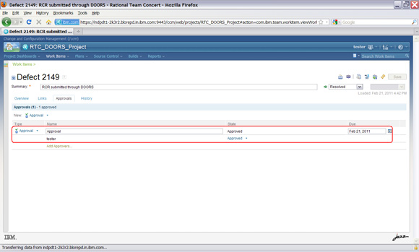

[Larger view of Figure 33.](https://www.ibm.com/developerworks/rational/library/integrate-rational-doors-and-rational-team-concert-change-management/fig33_lg.html)

**Apply changes made to the module**

1. Open the formal module of DOORS in Read-Only mode.
2. Select **Change Management > Requirements Change Request > Apply.**
3. When the Apply Requirements Change Request dialog displays the resolved Requirement Change Request, select the Requirement Change Request, and click **Apply** to apply the changes made to the requirements in the formal module (see Figure 34).

**Figure 34. Apply Requirements Change Request view in DOORS**

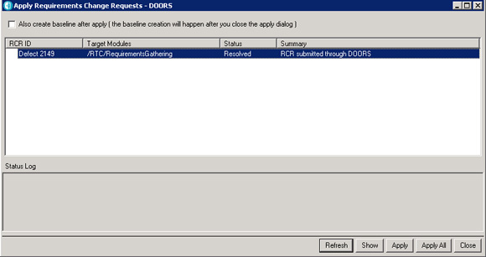

[Larger view of Figure 34.](https://www.ibm.com/developerworks/rational/library/integrate-rational-doors-and-rational-team-concert-change-management/fig34_lg.html)

Changes made to the module will then get applied.

**Manage an Implementation Requirements Request**

1. Start the Rational DOORS client by executing **doors.exe**.
2. Log in to DOORS as a user with Database Administrator privileges.
3. Open the formal module in Read-Only mode.
4. Click **Change Management > Configure Module**.
5. Select the configuration template for Rational Team Concert.
6. Select the **Enable Requirements Implementation** option shown in the Figure 35.

**Figure 35. Configure Module for Change Management view in DOORS**

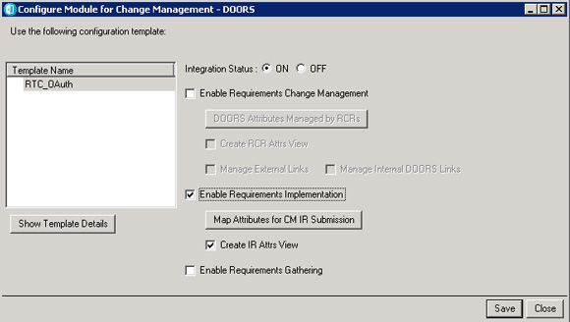

[Larger view of Figure 35.](https://www.ibm.com/developerworks/rational/library/integrate-rational-doors-and-rational-team-concert-change-management/fig35_lg.html)

1. Click **Save**.
2. Select the requirements that need to be implemented, right-click, and select Implementation **Request > Submit**.
3. Enter details in the Submit Request dialog window shown in the Figure 36.

**Figure 36. Submit Request form for the Implementation Request**

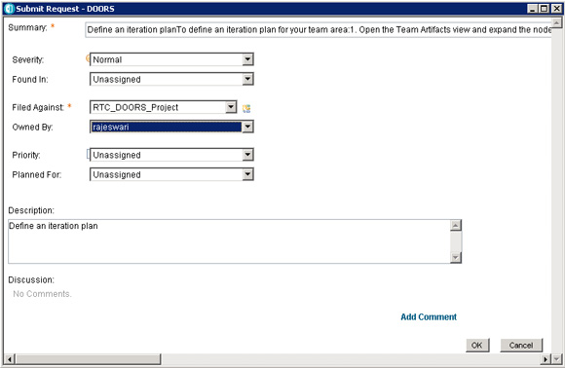

[Larger view of Figure 36.](https://www.ibm.com/developerworks/rational/library/integrate-rational-doors-and-rational-team-concert-change-management/fig36_lg.html)

1. Click **OK** to submit the Implementation Request.

Select the requirement in DOORS and view the link. An external link gets created for the Implementation Request submitted as shown in the Figure 37.

**Figure 37. External link created for Implementation Request in DOORS**

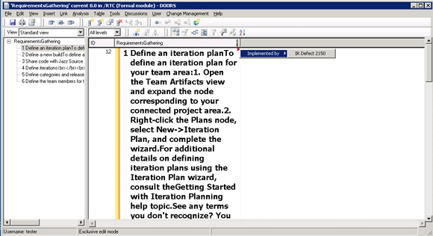

[Larger view of Figure 37.](https://www.ibm.com/developerworks/rational/library/integrate-rational-doors-and-rational-team-concert-change-management/fig37_lg.html)

1. Select the requirements that need to be implemented, right-click, and select **Implementation Request > Add**. This allows you to add additional Implementation Requests to the requirement, if any.

**Transition the Implementation Request to the Resolved state**

1. Launch IE or Firefox.
2. Type this URL in the address bar to start Rational Team Concert:  
   https://QualifyingServername:9443/ccm/  
   **Note:**Accept the *secured connection* certification.
3. Enter user ID and password, and then click **Log In**.
4. Enter the Implementation Request (Defect ID) in the search dialog, and view the defect details.
5. As a **Developer**, transition the defect to the **Resolved** state, after the requirement change gets implemented.
6. Log out of Rational Team Concert.

**Review the Show Activity Report**

1. Open the formal module of DOORS in Read-only mode.
2. Select the **Change Management > Show Activity Report** option.
3. Review the detailed requirement details, along with the Implementation Requirement details, as shown in the Figure 38.

**Figure 38. Implementation Requirement details**

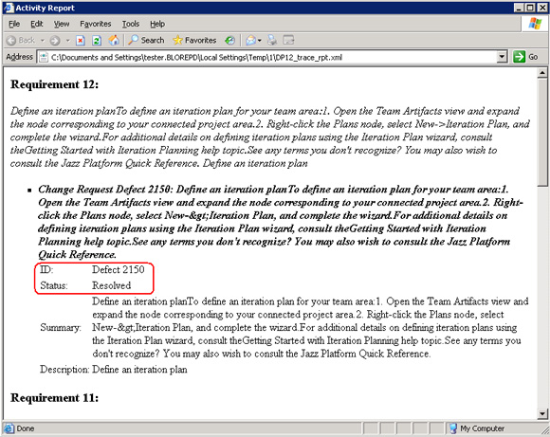

[Larger view of Figure 38.](https://www.ibm.com/developerworks/rational/library/integrate-rational-doors-and-rational-team-concert-change-management/fig38_lg.html)